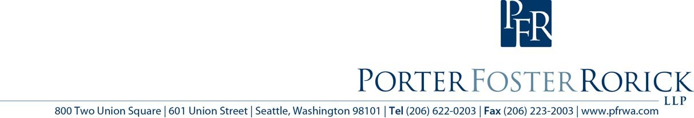

Public Records Disclosure Training
May 7, 9 am to 3 pm
Two Union Square Conference Center, Seattle

Join Tim Reynolds and Jay Schulkin of Porter Foster Rorick for a full day of hands-on training in processing public records requests and avoiding mistakes that lead to legal liability. This workshop will satisfy the legally-mandated training for district officials and public records officers. Registration is only $150 per person and includes lunch. Reserve a space by sending an e-mail with the names of attendees to info@pfrwa.com.

